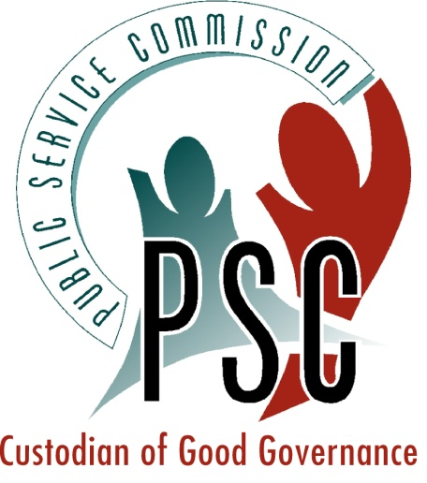

Internal Report

The Third Biennial South African Monitoring and Evaluation Association Conference

Theme: M&E 4 Outcomes:
Answering the “So what” question

Co-hosted by the South African Monitoring and Evaluation Association (SAMEA) and the Public Service Commission
5-9 September 2011
Emperors Palace Conference Centre, Kempton Park, Ekurhuleni, South Africa
TABLE OF CONTENTS

1. BACKGROUND 1
1.1 The co-hosting role of the PSC 1
1.2 Holding membership of international evaluation bodies 2
1.3 Presenting PSC work at seminars and training sessions 2
1.4 Engaging with the evaluation sector through discussion groups 2

2. THE THIRD BIENNIAL SOUTH AFRICAN MONITORING AND EVALUATION CONFERENCE 2
2.1 Pre-conference training programme 2
2.2 The Conference 4
2.2.1 Conference attendance 4
2.2.2 Keynote addresses 5
2.2.3 PSC speakers 5
2.2.4 Panel discussions 5
2.2.5 Parallel paper sessions 6
2.2.6 Virtual conference 6
2.2.7 Exhibitions 7
2.2.8 Poster sessions 7
2.2.9 Roundtable sessions 8
2.3 SAMEA Annual General Meeting 8
2.4 Conference leadership and administration 9

3. CONCLUDING REMARKS 9
3.1 Role of the PSC 9
3.2 Value of the PSC’s partnering with SAMEA 9
3.3 Assessment of the Conference 10

LIST OF TABLES

Table 1: PSC participants at the SAMEA Pre-training conference: 3
Table 2: Contributions on the virtual conference 6
Table 3: Electronic Media coverage 10

BACKGROUND

The Public Service Commission (PSC), based on its Constitutional mandate, has investigated, monitored and evaluated the Public Service for more than a decade. It began developing and implementing Monitoring and Evaluation (M&E) in 2000, in a context where there was no evaluation policy, limited M&E expertise and in general a lack of a performance culture in the Public Service. The PSC was thus faced with a situation where it had to develop receptiveness for M&E across government, and also develop M&E systems for the different policy thrusts and programmes. It engaged in extensive networking locally and internationally to inform its own M&E development in the country, and a decade later is the leading M&E institution in the country, whilst also having developed a reputation internationally as a leading M&E institution.

The PSC continues to be proactive in forging partnerships with evaluation experts, networks and institutions, which helps it to advance its mandate. In this regard, it has signed a Memorandum of Understanding with the South African Monitoring and Evaluation Association (SAMEA) as part of its effort to form compacts with professional institutions, in order to expand evaluation capacity. The PSC-SAMEA partnership has been very successful, resulting in three major biennial conferences over a 6 year period. This is in addition to it co-hosting several other M&E events during this period, such as focused training seminars and workshops. The PSC has built its networks through the following modalities:

- Co-hosting of international and national events
- Holding memberships of international evaluation bodies
- Presenting PSC work at conferences and internationally renowned training sessions
- Engaging with the evaluation sector through discussion groups

1.1 The co-hosting role of the PSC

Through co-hosting, the PSC has been able to shape key M&E conferences, as it has worked collaboratively on programme design, fundraising, selecting key note speakers, presenting papers, chairing sessions, design and organise pre-conference training sessions. These events as shown below have raised the profile of PSC work within the country and internationally.

- Third African Evaluation Association (AFREA) Conference, Cape Town (2004) – 61 countries, 500 delegates
- Development Evaluation Seminar in Tunis, Tunisia (2005) – 21 countries, 80 delegates
- Second International United Nations Development Programme (UNDP) Evaluation Office - 40 countries, 80 delegates
- Inaugural South African Monitoring and Evaluation Association (SAMEA) Conference (2007) – 400 person participation
- Second Biennial South African Monitoring and Evaluation Association (SAMEA) Conference (2009) – 450 person participation
- Third Biennial South African Monitoring and Evaluation Association (SAMEA) Conference (2011) – 1200 total participation

1.2 Holding membership of international evaluation bodies

The PSC is an institutional member of the International Development Evaluation Association (IDEAS), which it has held since 2009. In this regard it has participated in the IDEAS Global Assembly, Amman, Jordan, in 2011, where its work was presented. Dr IA Naidoo serves as an elected Board member of this association.

Several staff members hold membership of various evaluation associations, such as the European, United Kingdom, American and Canadian evaluation associations. The office is in the process of purchasing institutional membership of these bodies, to enable it to benefit from the professional publications and journals.

Reports on all of these events have been produced and enjoy wide-circulation, given the membership that SAMEA and AFREA has within international networks, such as the International Organisation for Cooperation in Evaluation (IOCE).

1.3 Presenting PSC work at seminars and training sessions

The PSC has participated in professional evaluation conferences in Asia, Africa, South and North America, Europe and Australia. Through these engagements the PSC has had its work discussed and critiqued by international experts, and through the communication platforms of these events, the work has been widely shared. Reports on all the events have been approved by the PSC.

The PSC has also engaged on a more focused basis by participating in international forums such as the Network of Networks on Impact Evaluation (NONIE), which specifically aims at promoting quality impact evaluation. In this regard, Dr Naidoo represents AFrEA on this network.

The most significant work which validates the PSC expertise may be found in the fact that the PSC co-teaches evaluation at the International Programme for Development Evaluation Training (IPDET). This engagement has been taking place since 2008, and the course has been favourably rated. Reports have been approved by the PSC.

1.4 Engaging with the evaluation sector through discussion groups

The PSC has actively engaged with evaluation networks and platforms, by presenting webinars, commenting on policy documents, engaging on methodology discussions, amongst other. This is with a view to keep abreast of the evaluation discipline.

THE THIRD BIENNIAL SOUTH AFRICAN MONITORING AND EVALUATION CONFERENCE

The Public Service Commission, in partnership with SAMEA hosted the third Biennial Monitoring and Evaluation Conference on 05-09 September 2011 in Gauteng. The event was structured into a Pre-conference training which took place from 05-07 September 2011 and the actual Conference which commenced on 07-09 September 2011. The theme of the conference was M&E 4 Outcomes: Answering the “So What” Question.

2.1 Pre-conference training programme

On 5-7 September 2011, SAMEA hosted 13 M&E professional developmental workshops. The workshops were highly interactive and provided delegates with an opportunity to acquire new skills, to sharpen existing skills and to share experiences amongst each other. Furthermore, these workshops were facilitated by national and international experts in the field of M&E. Annexure A provides further details on the pre-conference developmental workshops).

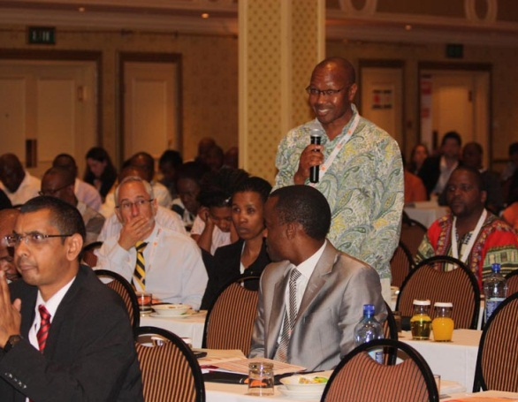
Attended by very senior officials from South Africa and neighbouring countries, the Pre-conference training was over-booked and had at least 66 delegates attending. The only training session that was sold out was coordinated and managed by the PSC team. This flagship training session was on “Designing and Implementing M&E Systems” and was presented by one of the world’s leading evaluation gurus, Dr Ray Rist of the World Bank in Washington DC. The training session on “From indigenous values to instruments and action in the context of developmental evaluation” was the least attended with about 13 delegates.

In addition, some of the PSC officials and Commissioners attended Pre-conference training. Table 1 below depicts the attendees from the PSC:

Table 1: PSC participants at the SAMEA Pre-training conference:
NAME | COURSE | TRAINER(S)
Ms C du Plessis | Better Evaluation (FAQ on Evaluation Methods)  Better Evaluation (FAQ on Evaluation Methods) | Prof Patricia Rogers
Mr O Makgari |  | Prof Patricia Rogers
Ms NS Sithole | Empowerment Evaluation | Dr David Fetterman
Ms JR Pheme | Empowerment Evaluation | Dr David Fetterman
Ms R Nelwamondo | Practical Solutions to Everyday Evaluation Challenges | Dr Andy Rowe
Dr TB Luthuli | Practical Solutions to Everyday Evaluation Challenges | Dr Andy Rowe
Ms N Gcwabe | Practical Solutions to Everyday Evaluation Challenges | Dr Andy Rowe
Ms N Gcwabe | Designing and Implementing M&E Systems | Dr Ray Rist
Mr B Mavimbela | Designing and Implementing M&E Systems | Dr Ray Rist
Mr F Dolamo | Designing and Implementing M&E Systems | Dr Ray Rist
Mr PB Nhlangothi | Designing and Implementing M&E Systems | Dr Ray Rist
Comm P Ndzimande | Designing and Implementing M&E Systems | Dr Ray Rist
Comm P Helepi | Designing and Implementing M&E Systems | Dr Ray Rist
Mr T Ramjettan | Data Gathering in Evaluation Research | Prof Gert Van Der Westhuizen
Ms S Mkhatshwa | Data Gathering in Evaluation Research | Prof Gert Van Der Westhuizen
Ms M de Jenga | Data Management System and Data Quality | Mr Peter Njaramba and Ms Annette Chingandu
Ms J Adams | Data Management System and Data Quality | Mr Peter Njaramba and Ms Annette Chingandu
Ms M Melene | Data Management System and Data Quality | Mr Peter Njaramba and Ms Annette Chingandu
Comm P Ndzimande | Participatory Project Reviews | Mr Scott Chaplowe
Comm S Mafanya | Participatory Project Reviews | Mr Scott Chaplowe
Comm M Mawasha | Participatory Project Reviews | Mr Scott Chaplowe
Ms F Mathoma | An Introduction to Outcome Mapping | Dr Kevin Kelly
Comm M Mawasha | An Introduction to Outcome Mapping | Dr Kevin Kelly
Comm M Mawasha | A New Wave of Innovation in Evaluation Theory & Practice | Dr Kevin Kelly

2.2 The Conference

Following the Pre-training sessions, the conference took place on 07-09 September 2011. The Conference aimed to sustain and deepen the advancement of M&E in the country. As the third Biennial Conference in the past 6 years, it further sought to achieve the following objectives:

- Improve the utilisation of Monitoring and Evaluation practices and findings in programme development, management, and implementation
- Enhance knowledge management and learning within organisations and programmes
- Focus on the challenges of building evaluation systems for tiered, multi-sectoral and multi-partnered programmes
- Build evaluation capacity and enhance information sharing
- Increase the use of M&E theory and practice
- Promote the development and adoption of M&E approaches and methods suitable to a South African and development context
- Increase the profile of South African M&E at national and international level
- Build an understanding of international developments and trends in M&E

The eight topics of the conference sessions covered the following M&E topics:

- M&E Approaches- Novel Approached or Ideas
- M&E in the Caring Professions
- USAID’s New Evaluation Policy and its Implications for M&E in Africa
- M&E in Education and Training
- Global Trends- Comparative Perspectives
- M&E Micro and Macro Systems
- Data Quality and Data Use
- Better Evaluation

2.2.1 Conference attendance

The conference was attended by approximately 560 participants. They represented the public sector, research and development agencies, the academic sector, NGO’s, private enterprises and M&E practitioners from all over South Africa and abroad. Amongst others, there were delegates from Botswana, Canada, Ghana, Germany, India, Kenya, Malawi, Nigeria, Pakistan, USA and South Africa.

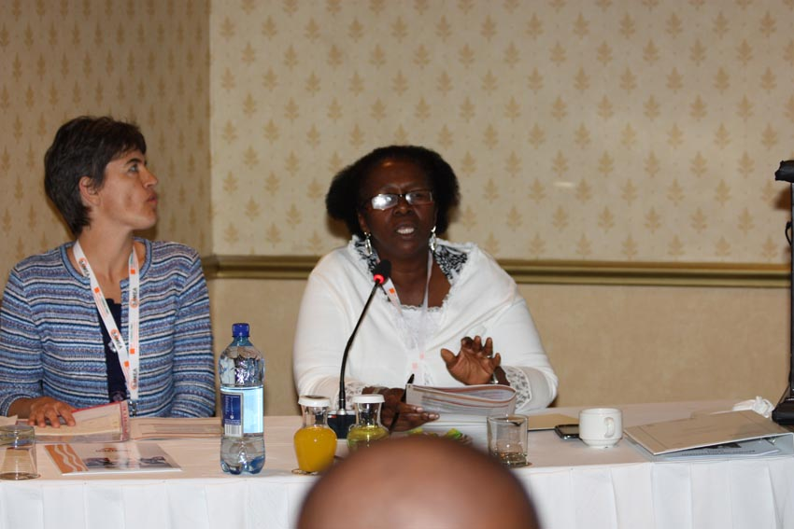
The PSC was represented at the Conference by the Chairperson, Mr B Mthembu, and five Commissioners, namely, Mr P Helepi, Mr S Mafanya, Mr M Mawasha, Mr D Mkhwanazi and Ms P Nzimande. Apart from the Commissioners, the PSC was represented by other officials from the M&E branch and Regional Offices.

2.2.2 Keynote addresses

The conference had three keynote addresses. These were:

- Mr B Mthembu – Chairperson of the Public Service Commission. He delivered the official opening address on the 7 September 2011, the first day of the Conference.
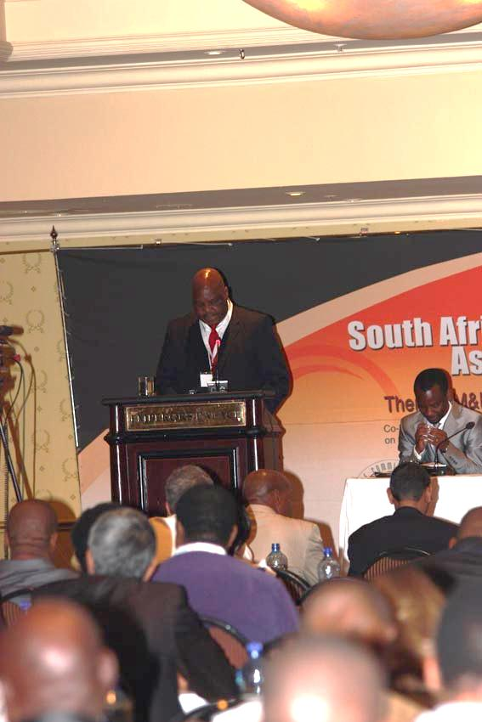
- Professor David Fetterman – Stanford University (formerly) delivered an address on: Using an Empowerment Evaluation Engine to Race Towards Social Injustice: A Response to the “So What” question on Thursday, 8 September 2011.
- Professor Sibongile Muthwa – Deputy Vice Chancellor [Administration], Nelson Mandela Metropolitan University presented on Locating M&E in the Context of a South African Developmental State. This was presented on the last day of the conference, 9 September 2011.

2.2.3 PSC speakers

The workshop boasted extremely powerful and useful content on M&E. PSC officials who contributed in this regard include:

- Dr Indran Naidoo (DDG: M&E) a panellists in the plenary, he presented on “Bringing about Good Governance in South Africa: An African Perspective”. Dr Naidoo also contributed to the virtual symposium on M&E in the South African Public Sector Context
- Mr Kobus van der Merwe (CD:GM) presented on “Measuring Institutional Performance of Public Service Departments and How this can help institutions”
- Ms Irene Mathenjwa (CD: SDCE) who presented on “Service Delivery Inspections in the Health Sector”.

2.2.4 Panel discussions

Panel discussions brought together specialists around specific themes. The panel discussions created lively debates and discussions amongst delegates and these are:

- Panel Session 1: Education Sector: Unpacking Education Evaluation Methodologies: Case Studies of Project, Programme and Provincial Evaluation Research
- Panel Session 2: SAMEA Board: Challenges With Measuring Outcomes – Perspectives From Evaluation Experience
- Panel Session 3: Emerging Evaluators’: Initial Impressions On The Value Of Evaluation For Achieving Outcomes And Influencing Programs
- Panel Session 4: Government Perspectives on M&E: Professionalization And Evaluation – Considered Explorations
- Panel Session 5: Rural Development: Rural Development And Poverty Reduction – Does Evaluation Lead To Tangible Benefits/Challenges And Assist Projects Achieve Goals
- Panel Session 6: Evaluation Systems: Mexico –Columbia And South Africa – Comparison Of M&E Systems

2.2.5 Parallel paper sessions

One hundred and six (106) presentations were made in the parallel sessions:

Parallel Oral/Paper presentation ‘A’

- Paper Session 1 & 2: M&E Innovations – Novel Approaches or Ideas
- Paper Session 3 & 4: M&E In The Caring Professions
- Paper Session 5: USAID’s New Evaluation Policy and Its Implications For M&E In South Africa

Parallel Oral/Paper presentation ‘B’

- Paper Session 1 & 2: M&E In Education and Training
- Paper Session 3: Global Trends – Comparative Perspective
- Paper Session 4 & 5: M&E Macro and Micro Systems
- Paper Session 6: Data Quality and Data Use
- Lunch Session: Better Evaluation

2.2.6 Virtual conference

Table 2 below highlights the contributions on the virtual conference:

Table 2: Contributions on the virtual conference
TOPIC | CONTRIBUTORS
M&E in the public sector: | - Indran Naidoo [DDG, Office of the Public Service Commission]: Monitoring and Evaluation in the South African Public Sector Context  - Ray Basson: Evaluation, Qualitative Approaches and Public Administration  - Katherine Hay: Evaluation Field Building in South Asia: Reflections, Anecdotes, and Questions  - Kevin Kelly: Non-governmental Health and Welfare Services in South Africa: What Evaluative Questions should we be Asking about the Current Environment?  - Stephen Porter: Strengthening Demand-driven Performance Monitoring and Evaluation
M&E innovations - novel approaches or ideas | - Patricia Rogers: Better Evaluation: Improving Evaluation Outcomes by Sharing Information about Evaluation Methods  - Andy Rowe: Getting Past the Stale RCT Debate: A New Approach to Evaluate Impacts
Global trends - Comparative Perspectives | - Donna Mertens: Social Justice and Evaluation: From Theory to Practice and Back Again  - Daniel Stufflebeam: Meta-evaluation: Lessons from the Real World  - Abraham Wandersman: Program Evaluation and Program Development  - Carol Weiss: On Theory-Based Evaluation: Winning Friends and Influencing People
M&E systems | - Jennifer Bisgard: Innovative methods to evaluate more effectively and cheaply  - FanieCloete and Babette Rabie: Toward evidence-based local economic development policy: Outcome indicators for identifying effective local economic development interventions in South Africa  - Errol Goetsch: Master of Excellence: the value and values M&E gives to organisations and their projects
M&E in the caring professions | - AJ Edge: Positive transfer from classroom to workplace? Evaluation of an HIV training programme for health care workers.
M&E in education and training - including skills development | - Benita Williams: Unpacking the Learner-Selection Suitcase: A Synthesis of Evaluation Findings from Learner – Directed Educational Improvement Initiatives.  - Johann Louw, Johan Muller and Colin Tredoux: Time-on-task, Technology and Mathematics Achievement  - Charles Potter , Peter Fridjhon and Gregg Ravenscroft: Using Test Results as a Basis for Identifying Instructional Needs and Monitoring Progress of Children in Schools and Classrooms
Case studies | - Ray Basson: Commitment in developing new educational sites in South Africa  - Dharmendra Chandurkar and Aparupa Negi: Process, Outcomes and Lessons Learnt: Implementing the Most Significant Change Technique for Monitoring and Evaluation of a Social and Behaviour Change Programme  - Stephanie Friend, Gordon Naidoo and Mark Creekmore: Participatory Evaluation in Teacher Development: An Application of Photo voice Methodology  - Sabrina Liccardo: An Evaluative Case Study of Transformation in South African Tertiary Education  - Donna Podems and Anna Davis: Developmental Evaluation and Systems Thinking: Applying the Concepts on a Social Innovation Project in Namibia  - Stephen Porter: End of the road for a rights-based approach? A case study of mobile technology in KwaZulu-Natal, South Africa  - Laurie Woollacott: An Evaluation of the Use of Mediated Interaction Groups for Enhancing Learning among First Year Engineering Students Lorenzo.

2.2.7 Exhibitions

The following organisations had exhibitions of their work at the conference:
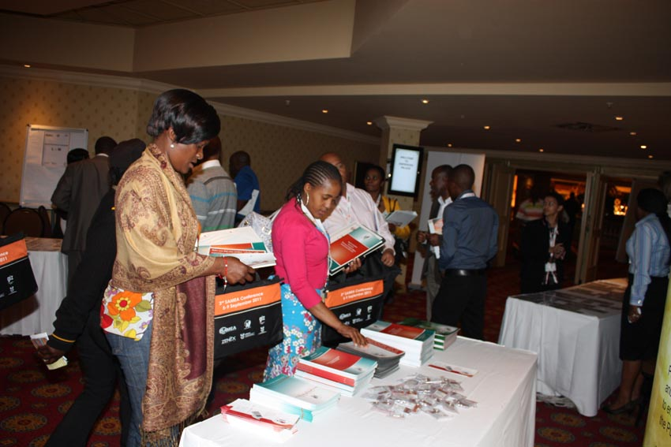
- Auditor-General of South Africa
- Creative Consulting & Development Works
- FEEDBACK Research and Analytics
- PEPFAR FELLOWSHIP Programme
- Public Service Commission of South Africa
- Southern Hemisphere Consultants

2.2.8 Poster sessions

There were also Posters on the following topics:

- Development of Project Evaluation Scorecard.
- Comparative Study of the Baseline Survey and Mid- Term Evaluation of the Releasing Confidence and Creativity 0-3 Programme.
- Supplementing Traditional Logical Framework Approaches with MSC (Most Significant Change theory): Evaluating an HIV/AIDS Project in Rural Limpopo Province.
- The Influence of Developing an M&E Framework on Programme Design: A Case Study from the Lesotho Agricultural Sector.
- Programme Performance Assessment as an Evaluation tool in Public Health Management.
- Evaluating Home Based Care Projects Using a Quality of Life Scale in Three Sites in Malawi, South Africa and Zambia.

2.2.9 Roundtable sessions

The above-mentioned papers covered a wide spectrum of M&E topics and were generally of a very high standard. There were also oral presentations made on various M&E topics by distinguished M&E practitioners. Additionally, there were roundtable sessions on:

- Roundtable 1: Enhancing Evaluation Quality Through Evaluation Quality Assurance Systems presented by Casper Merkle, UN; Edward Addai, UN; Michael Carbon, UN; and Adeline Sibanda, AGDEN.

- Roundtable 2: Assessing Monitoring and Evaluation Readiness 4 Outcome Management presented by Sandiran Premakanthan, SICS Canada.

- Roundtable 3: Is Knowledge about Evaluation Use and Methods Useful? presented by Dr Andy Rowe, ARCeconomics; Linda Lee, PR Larry Bremner, Proactive Research.

- Roundtable 4: The African Evaluation Guidelines as a Tool for Ensuring the Quality of Evaluations Commissioned by Private Sector Donors presented by Benita Williams.

2.3 SAMEA Annual General Meeting

The final part of the conference was set aside for the SAMEA Annual General Meeting and the board elections which took place on Thursday, 8 September 2011. The term of office of the following board members of SAMEA came to an end:

- Mr David Molapo
- Ms Candice Morkel
- Ms Christel Jacob

Elections of new board members that replaced the above outgoing members were held and the following new members were elected:

- Ms Irene Mathenjwa
- Mr Jabu Mathe
- Mr Terence Beney

Mr Jabu Mathe has since left the PSC to join the DPME in the Presidency. This transfer has been viewed as strategic for the PSC and SAMEA because the Presidency is a crucial partner in the M&E community.

2.4 Conference leadership and administration

As a co-host, the PSC played a pivotal role in the coordination and general management of the conference. One of the key roles the PSC played was in securing of funding and sponsorship for the overall conference. This resulted in a profit that was made which will go back to SAMEA.

Under the leadership of DDG: M&E Dr Indran Naidoo, a PSC team was formed to coordinate the various logistical aspects of the Conference. The team comprised of:

- Ms Irene Mathenjwa
- Ms Noqobo Gcwabe
- Ms Mpho Ngoasheng

This team was also supported by the Communications team who were instrumental in taking pictures, videos and the overall branding of the Conference. Communications also coordinated the media and print coverage. This team comprised of:

- Mr Humphrey Ramafoko
- Mr Ricardo Mahlakanya
- Mr Mocheta (Cliff) Monama

CONCLUDING REMARKS

3.1 Role of the PSC

Under the leadership of the Deputy Director-General M&E Dr Indran Naidoo, the PSC played a vital role in the co-development of the programme with SAMEA. Also, the PSC along with other partners such as GIZ, played a coordination role during the conference including planning and coordinating the training event on Designing and Implementing M&E Systems by Dr Ray Rist at PALAMA on 5&6 September 2011.

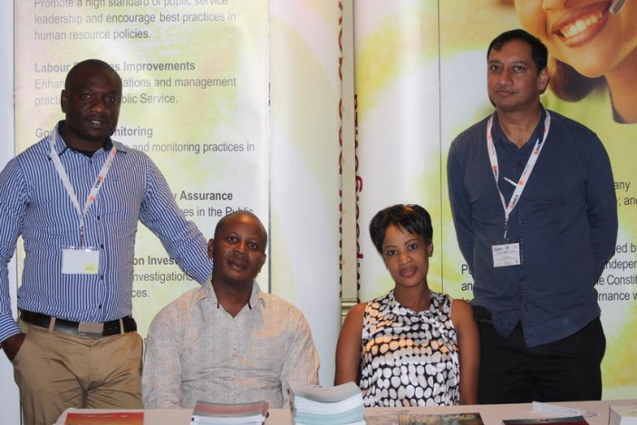
Strategic stakeholder engagement was also done very effectively by the PSC. Critical stakeholders such as the DPME were well profiled at the conference as key M&E partners. Other stakeholders from various influential institutions were also roped in by the PSC as delegates and speakers at the conference.

Furthermore, the PSC was responsible for the branding of the overall conference as well as conference material including the conference bags, banners, programme as well as the name tags. Some of the media exposure of the conference was also coordinated by the PSC.

3.2 Value of the PSC’s partnering with SAMEA

The Conference provided good exposure and advocacy opportunities for the PSC. Benefits accrued to the PSC for partnering with SAMEA on this important conference included the following:
- By co-hosting the event, the PSC got a lot of national and international exposure. The Conference afforded the PSC an opportunity to be recognised as an institution of high credibility on M&E. The brand name of the PSC was well-carried even by attending officials.

- Exhibiting PSC’s published evaluation reports was another positive notch for the organisation. The presence of a PSC table where M&E material were showcased and made available to delegates was good branding for the organisation.

- A number of Commissioners and officials from the Office attended the conference and they were exposed to M&E learning and to evaluation work of other practitioners. Much of the evaluation work presented could serve as a benchmark for the work of the PSC with regard to the academic and research rigour in the future.

- PSC Commissioners and officials got professional exposure either as chairs of sessions, presenters in sessions or moderators. This exposure is critical in building a career in the evaluation community.

3.3 Assessment of the Conference

3.3.1 Media

Electronic and print communication had to be approved by SAMEA, THE PSC and GIZ prior to being released. There was an article on the Business Day on 07 September 2011 on the conference and Table 3 below lists the electronic media coverage:

Table 3: Electronic Media coverage
OFFICIAL | MEDIUM/ COVERAGE | DATE
Dr Indran Naidoo | SABC Radio News (All Radio stations) | 04 September 2011
Mr Sol Molapo | Ligwalagwala FM | 05 September 2011
Dr Indran Naidoo | SAFM (morning, midday &afternoon) | 05,06,07 September 2011
Commissioner Paul Helepi | Lesedi FM | 06 September 2011

3.3.2 Innovation
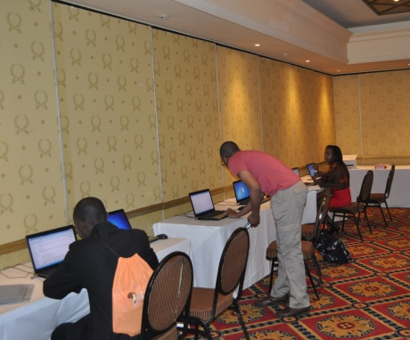
One of the impressive elements about this SAMEA conference was the innovation and the technology-driven approach that it took.

This was testimony to the notion that the PSC strives to be on par with global standards of using information communication technology (ICT) for development.

This was done in the following ways:

- The workshop was basically paperless (except for the programme) and all the presentations were loaded on memory sticks.
- There was an internet-connected communication centre at the Conference venue that was used to load presentations and to also vote for SAMEA board members online.
- The conference was captured on video which has been developed and circulated.
- There was a virtual conference running in parallel over two weeks.

3.3.3 Overall assessment of the learning event

The Conference was a resounding success. Delegates who had attended from all parts of the world testified to the high quality of the dialogue, the high quality of keynote speakers, the large number and diversity of the participants, the good venue and efficient organisation.

A total of 119 evaluation forms were completed and submitted.The overall score was good, and this shows that the participants who completed the evaluation forms were happy with the event.

As a way forward, the following measures are proposed:

3.3.4 Conference Proceedings

A full conference report will soon be made available for all participants to peruse. It will be posted on the SAMEA and PSC websites. Also, 1000 DVDs on the conference proceedings have been made and given to participants. As a co-host, the PSC will collaborate with SAMEA in producing Conference proceedings. The proceedings will be made available to the PSC in the near future.

See From Policy to Results, Sergone, M. (2010) UNICEF.
Reports on all the events have been approved by the PSC.

