

MONITORING FACT SHEET ON COMPLAINTS LODGED WITH THE PUBLIC SERVICE COMMISSION DURING THE 2008/2009 FINANCIAL YEAR

September 2009

TABLE OF CONTENTS

Introduction…………………………………………………………………………………… | 01
Objectives of the Fact Sheet……………….………………………………………………. | 01
The number of complaints lodged with the PSC through the NACH has increased..... | 02
The number of complaints lodged with the PSC through the Complaints Rules has decreased………………………………………………………………………………….…. | 03
The Public Protector dealt with a substantial number of complaints……….……….….. | 03
Departments implicated in complaints lodged with the PSC………………………….… | 04
The majority of complainants identified themselves…………………………………..…. | 06
Sources of complaints lodged with the PSC………………………………………..…..… | 07
Nature of complaints lodged with the PSC……………………………………………….. | 07
The highest number of complaints lodged with the PSC related to unethical behaviour…………………………………………………………………………..…………. | 09
The management of complaints lodged with the PSC………………………….……….. | 10
The number of complaints finalised increased…………………………...………….…… | 10
A high percentage of complaints dealt with by the Public Protector were finalised…... | 10
Departments from whom no feedback was received……………………………………. | 12
Reasons for finalising complaints…………………………………………………….……. | 12
Desk-top audits preceded 38% of complaints closed……………………………………. | 13
The number of complaints finalised increased…………………………………………… | 13
The number complaints found to be substantiated decreased….……………………… | 14
Conclusion…………………………………………………………………..……………….. | 14

LIST OF FIGURES AND TABLES

Figure 1: | Number of complaints lodged with the PSC through the NACH during 2008/2009.................................................................................................... | 05
Figure 2: | Number of complaints lodged with the PSC through the Complaints Rules during 2008/2009……………………................................................. | 05
Figure 3: | Number of complaints dealt with by the Public Protector in 2007/2008 impacting on provinces……………………………………………..…………. | 06
Figure 4: | NACH complainants in 2008/2009 who remained anonymous or  revealed their identity………………………………………………………….. | 06
Figure 5: | Nature of complaints lodged with the PSC during 2008/2009…..…………. | 09
Figure 6: | Status of complaints lodged with the PSC during 2008/2009…..…………. | 11
Figure 7: | Complaints lodged with the PSC that were finalised and closed as a result of the lack of locus standi, or desk-top audits conducted……..……. | 14
Table 1: | Total number of complaints lodged with the PSC through the NACH…… | 02
Table 2: | Total number of complaints lodged with the PSC through the  Complaints Rules…………………..………………………………………… | 03
Table 3: | Number of complaints handled by the Public Protector and the PSC respectively…………………………………………………….……………….. | 04
Table 4: | Source of complaints lodged with the PSC through the NACH…….…….. | 07
Table 5: | Source of complaints lodged with the PSC through the Complaints Rules……………………………………………………………………………. | 07
Table 6: | Nature of complaints lodged with the PSC through the NACH…..……..… | 08
Table 7: | Nature of complaints lodged with the PSC through the Complaints Rules……………………………………………………………………………. | 08
Table 8: | Nature of complaints lodged with the PSC during 2008/2009 through the NACH and the Complaints Rules…………………………….……….……. | 09
Table 9: | Status of complaints lodged with the PSC through the NACH……….…… | 10
Table 10: | Status of complaints lodged with the PSC through the Complaints  Rules………………………………………………………………….………… | 10
Table 11: | Number of complaints dealt with by the Public Protector and the PSC respectively that were finalised……………………………………….………. | 11
Table 12: | Complaints lodged with the PSC during 2008/2009, referred to departments with no responses forthcoming…………..……………………. | 12
Table 13: | Number of complaints lodged with the PSC through the NACH that were finalised and closed……………………………………………..….…………. | 12
Table 14: | Number of complaints lodged with the PSC through the Complaints Rules that were finalised and closed……………………..……..………..…. | 13
Table 15: | Outcome of investigations and desk-top audits conducted by the PSC..… | 14

Introduction  Objectives of the Fact Sheet  The number of complaints lodged with the PSC through the NACH has increased  The number of complaints lodged with the PSC through the Complaints Rules has decreased  The Public Protector dealt with a substantial number of complaints | Complaints regarding the Public Service are lodged with the Public Service Commission (PSC) in terms of two access mechanisms, namely the Rules of the PSC for lodging of complaints regarding the Public Service and the National Anti-Corruption Hotline (NACH). These complaints relate to a wide variety of issues ranging from maladministration and corruption to poor service delivery. An analysis of the complaints provides useful information to Parliament, the legislatures, the Executive and Public Service leadership on areas of risk in the Public Service. The PSC, therefore, commenced during 2005 to produce reports and fact sheets in this regard. Baseline information was established with a report on the analysis of trends on complaints lodged with the PSC during the 2004/2005 and 2005/2006 financial years, followed by a second report covering the 2006/2007 financial year and a fact sheet covering the 2007/2008 financial year. These reports were confined to statistics regarding the number, nature and handling of complaints lodged with the PSC.  In view of the overlap in the constitutional mandates of the Public Protector and the PSC, and in order to avoid duplication when dealing with complaints regarding the Public Service, a Memorandum of Understanding (MoU) was entered into between the Public Protector and the PSC. In terms of this MoU, the Public Protector investigates complaints from the general public regarding the conduct of Government agencies or officials, whilst the PSC investigates complaints by public servants. This Fact Sheet reflects statistics on complaints lodged with the PSC as well as the Public Protector, including those cases referred to the Public Protector.  The objectives of the Fact Sheet are to –  - provide an overview of the number of complaints lodged, the sources from which the complaints are received, the departments implicated, the type of complaints and the stages of investigations;  - establish trends emanating from complaints lodged and investigated; and  - establish trends in complaints lodged with the PSC, and those lodged with the Public Protector during the same period.  As was the case with the previous reports, for comparative purposes, corresponding statistics in respect of the two previous financial years are also provided.  During the 2008/2009 financial year, a total of 322 complaints were lodged with the PSC. Of these, 208 complaints (i.e. 65%) were lodged through the NACH (although the NACH was established for the reporting and management of corruption related complaints, in practice a large proportion of service delivery and non-corruption related complaints are also lodged with the PSC, as reflected in this fact sheet). The remaining 114 complaints (i.e. 35%) were lodged with the PSC through the Complaints Rules. A summary of complaints lodged with the PSC through the NACH during the 2008/2009 financial year is reflected in Table 1 below. For comparative purposes statistics in this regard in respect of the preceding two financial years are also reflected.  TABLE 1: TOTAL NUMBER OF COMPLAINTS LODGED WITH THE PSC THROUGH THE NACH  Whilst there was a significant decline in the number of complaints lodged with the PSC through the NACH during the 2007/2008 financial year, an increase of 31% in this regard was experienced during the 2008/2009 financial year, i.e. from 159 complaints in the 2007/2008 financial year to 208 complaints in 2008/2009. The number of complaints lodged with the PSC through the NACH impacting on National Departments increased from 88 in the 2007/2008 financial year to 125 in 2008/2009. A similar trend was experienced with complaints in respect of Provincial Departments in that the number of complaints lodged with the PSC through the NACH increased from 51 in the 2007/2008 financial year to 72 in 2008/2009.  However, a decrease was experienced in the number of complaints lodged with the PSC through the NACH during the period under review impacting on Local Government, i.e. from 30 complaints lodged in 2006/2007 to 19 complaints in 2007/2008 and only 11 in 2008/2009.  The 31% increase in the number of complaints lodged with the PSC through the NACH during the 2008/2009 financial year could be attributed to an increase in awareness of the NACH, as well as an increase in confidence in the NACH as a complaint mechanism.  In addition, 114 complaints were also lodged with the PSC during the 2008/2009 financial year through the Complaints Rules. Details in this regard are reflected in Table 2 below:  TABLE 2: TOTAL NUMBER OF COMPLAINTS LODGED WITH THE PSC THROUGH THE COMPLAINTS RULES  From Table 2 above a steady decline is observed in the number of complaints lodged with the PSC through the Complaints Rules, i.e. a 20% decline from 218 complaints lodged in 2006/2007 to 174 complaints lodged in 2007/2008, followed by a further decline of 35% from 174 complaints lodged in 2007/2008 to 114 complaints in 2008/2009.  The majority of complaints involved National Departments. This is in line with the trend observed in respect of complaints lodged with the PSC through the NACH during the 2008/2009 financial year, as reflected in Table 1.  However, complaints lodged with the PSC through the Complaints Rules relating to the Local Sphere of Government increased from 4 in the 2007/2008 financial year to 12 in 2008/2009. These were referred to the Public Protector in terms of the MoU for further handling.  A comparison of complaints handled by the Public Protector and the PSC revealed that the Public Protector dealt with a substantial larger number of complaints than the PSC during the 2007/2008 financial year. Unfortunately statistics regarding the number of complaints handled by the Public Protector during the 2008/2009 financial year could not be obtained in time to include them in this Fact Sheet and will be reflected in the next report of this nature. The comparative details are nevertheless as follows:  TABLE 3: NUMBER OF COMPLAINTS HANDLED BY THE PUBLIC PROTECTOR AND THE PSC RESPECTIVELY  *Note: The total number of complaints not only applies to complaints referred to the Public Protector by the PSC but includes all complaints dealt with by the Public Protector during this period.  Contrary to the state of affairs regarding complaints lodged with the PSC, the majority of complaints handled by the Public Protector during 2007/2008 involved Provincial Departments  The Public Protector’s mandate is largely confined to investigations in that section 182 of the Constitution of the Republic of South Africa, 1996, and the Public Protector Act, 1994, stipulate that the Public Protector has the power to “… investigate any conduct in state affairs; or in the public administration in any sphere of government, that is alleged or suspected to be improper or to result in any impropriety or prejudice”. All the Public Protector’s human and financial resources are therefore geared towards the conducting of investigations.  Investigations into complaints, however, only form part of the PSC’s much broader mandate which includes monitoring and evaluation and the promotion of constitutional values and principles. Compared to the Public Protector, the PSC therefore has limited investigative capacity. As a result of these limitations the PSC has had to adapt its investigative methodology by conducting primarily desk-top audits of complaints received. Such an approach has limitations in that the PSC is dependent on departments to provide it with documentary evidence. Long delays are experienced in obtaining such information from departments and in many instances complete documentation cannot be provided due to inadequate record keeping by departments.
  Institution involved | 2006/2007 |  |  | 2007/2008 |  |  | 2008/2009
  National Departments | 123 | (46%) | 88 |  | (55%) | 125 |  | (60%)
  Provincial Departments | 110 | (41%) | 51 |  | (32%) | 72 |  | (35%)
  Local Government | 30 | (11%) | 19 |  | (12%) | 11 |  | (5%)
  Private Companies | 5 | (2%) | 1 |  | (1%) | -
  TOTAL | 268 |  | 159 |  |  | 208
  Institution involved | 2006/2007 |  | 2007/2008 |  | 2008/2009
  National Departments | 118 | (54%) | 97 | (56%) | 50 | (44%)
  Provincial Departments | 72 | (33%) | 53 | (30%) | 43 | (38%)
  Local Government | 2 | (1%) | 4 | (2.5%) | 12 | (10%)
  Private Companies | 18 | (8%) | 7 | (4%) | 5 | (4%)
  National & Provincial Departments | - |  | 7 | (4%) | 2 | (2%)
  Unknown | 8 | (4%) | 6 | (3.5%) | 2 | (2%)
  TOTAL | 218 |  | 174 |  | 114
  Institution involved | Public Protector |  | PSC
  Institution involved | 2007/2008  2007/2008 |  | 2008/2009
  Nat. Departments | 2 693 | (20.5%) | 185 | (56%) | 175 | (54%)
  Prov. Departments | 10 520 | (79%) | 104 | (31%) | 114 | (35%)
  Local Government | 3 | (0.02%) | 23 | (7%) | 23 | (7%)
  Private Companies | - |  | 8 | (2%) | 5 | (2%)
  Nat/Prov Departments | - |  | 7 | (2%) | 2 | (1%)
  Other State organs | 7 | (0.05%) | - |  | -
  Unknown | - |  | 6 | (2%) | 3 | (1%)
  TOTAL (100%) | 13 223* |  | 174 |  | 322
Departments implicated in complaints lodged with the PSC  The majority of complainants identified themselves  Sources of complaints lodged with the PSC  Nature of complaints lodged with the PSC  The highest number of complaints lodged with the PSC related to unethical behaviour  The management of complaints lodged with the PSC  The number of complaints finalised increased  A high percentage of complaints dealt with by the Public Protector were finalised  Departments from whom no feedback was received  Reasons for finalising complaints  Desk-top audits preceded 38% of complaints closed  The number of complaints finalised increased  The number of complaints found to be substantiated decreased  CONCLUSION | Trends in respect of the number of complaints lodged with the PSC through the NACH during the 2008/2009 financial year are graphically illustrated as follows per Province (statistics on National Departments are also indicated for comparative purposes):  FIGURE 1: NUMBER OF COMPLAINTS LODGED WITH THE PSC THROUGH THE NACH DURING 2008/2009  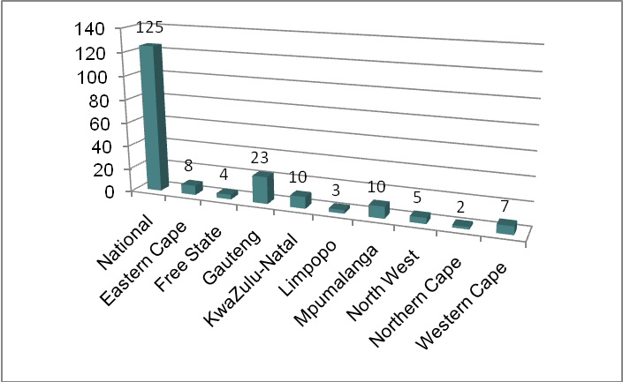  From the above figure it is observed that the least number of complaints lodged with the PSC through the NACH during the 2008/2009 financial year impacted on departments in the Northern Cape. This is a continuation of the trend observed in 2007/2008. A further consistent trend is the fact that the highest number of complaints lodged with the PSC through the NACH in 2008/2009 impacted on departments in Gauteng.  The number of complaints lodged with the PSC through the Complaints Rules impacting on the Provinces is as follows:  FIGURE 2: NUMBER OF COMPLAINTS LODGED WITH THE PSC THROUGH THE COMPLAINTS RULES DURING 2008/2009  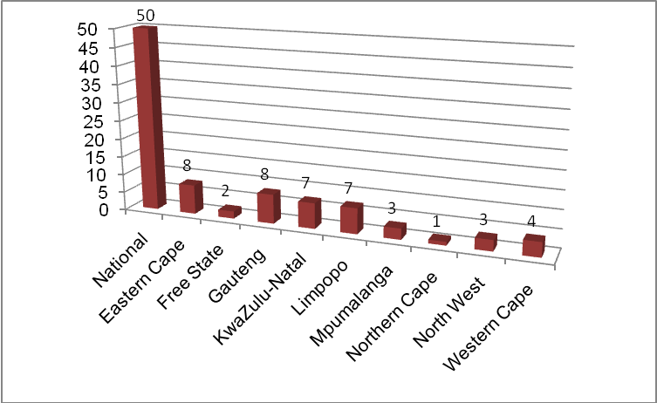  The least number of complaints lodged with the PSC through the Complaints Rules during the 2007/2008 as well as the 2008/2009 financial year, were in respect of departments in the Northern Cape, whilst the highest number of complaints lodged during these two financial years impacted on departments in Gauteng and the Eastern Cape. This is graphically illustrated as follows:  For comparative purposes, the 10 520 complaints dealt with by the Public Protector during the 2007/2008 financial year impacting on Provincial Departments/Institutions, indicated in Table 3 above, are illustrated as follows (as was the case in figures 1 and 2, statistics on National Departments/Institutions are also indicated for comparative purposes):  FIGURE 3: NUMBER OF COMPLAINTS DEALT WITH BY THE PUBLIC PROTECTOR IN 2007/2008 IMPACTING ON PROVINCES  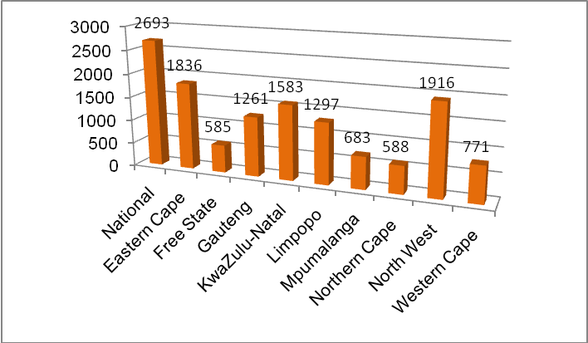  From the above figure it is noted that as was the case with complaints lodged with the PSC, the Provinces where the least number of complaints were dealt with by the Public Protector during the 2007/2008 financial year were the Free State and the Northern Cape.  When complaints are lodged with the PSC through the NACH, complainants can either remain anonymous, or reveal their identity. In Figure 4 below it is reflected that during the 2008/2009 financial year the majority of complainants who made use of the NACH, i.e. 113 or 54%, chose to identify themselves.  FIGURE 4: NACH COMPLAINANTS IN 2008/2009 WHO REMAINED ANONYMOUS OR REVEALED THEIR IDENTITY  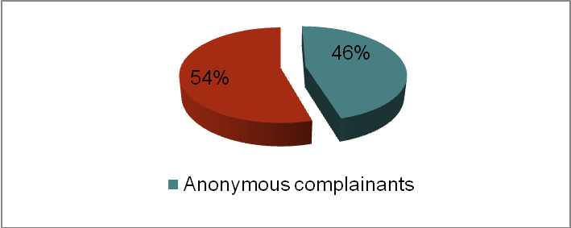  The sources of complaints, as well as comparative statistics relating to the 2006/2007 to 2008/2009 financial years, are reflected in detail in tables 4 and 5 below:  TABLE 4: SOURCE OF COMPLAINTS LODGED WITH THE PSC THROUGH THE NACH  As illustrated in Table 4 above, an increase was experienced during the period under review in the percentage of NACH complainants who chose to reveal their identity, i.e. from only 44% in the 2006/2007 financial year to 46% and 54% in 2007/2008 and 2008/2009, respectively. This could be indicative of the success of whistleblower-protection legislation and initiatives, as well as the trust placed by complainants in the NACH as an access mechanism.  TABLE 5: SOURCE OF COMPLAINTS LODGED WITH THE PSC THROUGH THE COMPLAINTS RULES  *Note: Own accord investigations are reported in the PSC’s Annual Reports  Whilst the majority of complaints in 2006/2007 were lodged by public servants, members of the public were the major source of complaints during 2007/2008 followed by public servants and anonymous complainants. As illustrated in Table 5 above, this trend was repeated in 2008/2009.  In addition to the sources of complaints lodged with the PSC, statistics of the matters these complaints relate to are also maintained. Tables 6 and 7 below provides an overview of the nature of the complaints lodged with the PSC through the NACH and the Complaints Rules respectively during the period under review:  TABLE 6: NATURE OF COMPLAINTS LODGED WITH THE PSC THROUGH THE NACH  *Note: Although a total of 208 complaints were lodged with the PSC through the NACH during 2008/2009, in one instance it was not possible to determine the nature of the complaint due to the lack of information provided by an anonymous complainant.  As illustrated in Table 6 above, the majority of complaints lodged with the PSC through the NACH during the 2008/2009 financial year related to unethical behavior (i.e. 134 or 66% of the complaints lodged) followed by HR related complaints (i.e. 30 or 14%). This trend is a repetition of the previous financial years where the largest number of complaints lodged also related to unethical behaviour (i.e. 74 or 46% of the complaints in 2007/2008 and 135 or 50% in 2006/2007), followed by those relating to HR matters (i.e. 49 complaints or 31% in 2007/2008 and 53 or 20% in 2006/2007).  TABLE 7: NATURE OF COMPLAINTS LODGED WITH THE PSC THROUGH THE COMPLAINTS RULES  Note: The above totals exclude cases where the nature of complaints could not be determined as a result of a lack of information provided by the complainants. In such instances steps are taken by the PSC to obtain outstanding information from complainants, where possible.  As was the case during the previous two financial years, the largest number of complaints lodged with the PSC through the Complaints Rules during the 2008/2009 financial year related to HR issues such as irregularities during the filling of posts or irregular promotions (i.e. 32 complaints or 29%).  In terms of the combined number of complaints lodged with the PSC during the 2008/2009 financial year through the NACH and the Complaints Rules, however, the highest number, i.e. 145 (representing 46% of all complaints lodged) related to unethical behaviour. The second highest combined number of complaints lodged with the PSC during this period was 62 (i.e. 19.5%) and related to HR matters, e.g. the recruitment and selection process, as well as appointments and promotions.  TABLE 8: NATURE OF COMPLAINTS LODGED WITH THE PSC DURING 2008/2009 THROUGH THE NACH AND THE COMPLAINTS RULES  Graphically, the trends regarding the nature of complaints lodged with the PSC during the 2008/2009 financial year is illustrated as follows:  FIGURE 5: NATURE OF COMPLAINTS LODGED WITH THE PSC DURING 2008/2009  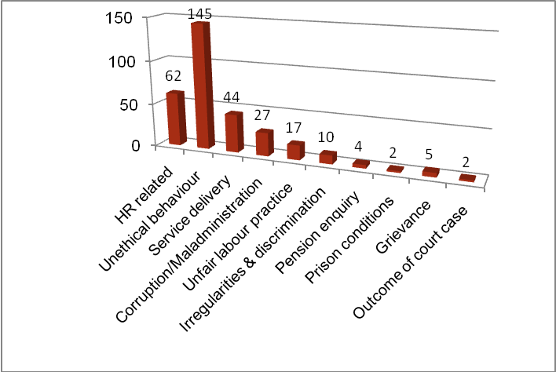  Out of the 208 complaints lodged with the PSC through the NACH during the 2008/2009 financial year, 65 (i.e. 31%) were referred to departments to investigate and provide feedback to the PSC. Departments, however, acknowledged receipt only in respect of 20 complaints (i.e. 10%) referred to them for investigation, whilst reminders had to be submitted in 23 cases (i.e. 11%). Trends in this regard, as well as the number of complaints finalised compared to the previous two financial years, are reflected in Table 9 below:  TABLE 9: STATUS OF COMPLAINTS LODGED WITH THE PSC THROUGH THE NACH  As illustrated in the above table the number of complaints lodged through the NACH that were finalised increased from 7% in 2006/2007 to 25% in 2008/2009. This is as a result of changes in the methodology followed by the PSC when dealing with complaints, e.g. liaising telephonically with departments, and/or the involvement of Resident Public Service Commissioners in the case of provincial departments, regarding responses/feedback.  The status of complaints lodged with the PSC through the Complaints Rules is reflected in Table 10 below. The number of complaints finalised by the PSC increased from 35% in the 2006/2007 financial year to 60% in 2008/2009.  TABLE 10: STATUS OF COMPLAINTS LODGED WITH THE PSC THROUGH THE COMPLAINTS RULES  A much larger number of complaints dealt with by the Public Protector during the 2007/2008 financial year were finalised. Comparative statistics of the cases that were finalised by the PSC and the Public Protector in the 2007/2008 and 2008/2009 financial years are indicated in Table 11 below:  TABLE 11: NUMBER OF COMPLAINTS DEALT WITH BY THE PUBLIC PROTECTOR AND THE PSC RESPECTIVELY THAT WERE FINALISED  As indicated previously, the Public Protector has a much larger dedicated capacity for the conducting of investigations. The PSC on the other hand is very much reliant on feedback from departments as it has had to adapt its investigative methodology by conducting primarily desk-top audits of complaints received. Understandably, delays experienced in obtaining such information from departments inhibit the ability of the PSC to finalise complaints.  The status of the remaining 202 complaints that were not finalised by the PSC during 2008/2009 is graphically illustrated as follows:  FIGURE 6: STATUS OF COMPLAINTS LODGED WITH THE PSC DURING 2008/2009  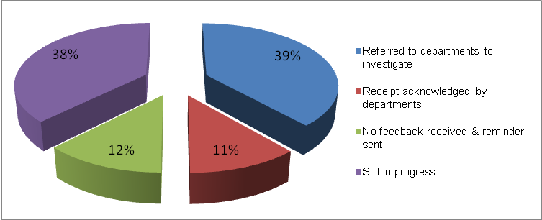  Although 78 complaints (i.e. 39%) were referred to departments for investigation, receipt was acknowledged only in respect of 23 of these complaints (i.e. 11%). Of these, 20 complaints were lodged through the NACH and 3 through the Complaints Rules.  As far as the 38% of complaints that were still in the process of being investigated are concerned, analysis of documentation provided by departments was in progress by the end of the financial year.  In terms of 23 of the complaints lodged with the PSC through the NACH during the 2008/2009 financial year and referred to departments to investigate, no feedback was received. Subsequently, the PSC had to issue reminders. The same applies to two complaints lodged through the Complaints Rules during the same period (see Table 10).  Details relating to those departments from whom no feedback was received during the 2008/2009 financial year, and to whom reminders had to be submitted, are reflected in Table 12:  TABLE 12: COMPLAINTS LODGED WITH THE PSC DURING 2008/2009, REFERRED TO DEPARTMENTS WITH NO RESPONSES FORTHCOMING  Complaints lodged with the PSC, falling within the PSC’s constitutional mandate, are only regarded as finalised once investigated and sufficient evidence has been obtained to prove that the allegations are substantiated or not. The reasons for finalising and closing complaints lodged with the PSC during the 2008/2009 financial year (see tables 9 and 10 above) are indicated in tables 13 and 14 below. Once again, statistics relating to the previous two financial years are also provided for comparative purposes.  TABLE 13: NUMBER OF COMPLAINTS LODGED WITH THE PSC THROUGH THE NACH THAT WERE FINALISED AND CLOSED  TABLE 14: NUMBER OF COMPLAINTS LODGED WITH THE PSC THROUGH THE COMPLAINTS RULES THAT WERE FINALISED AND CLOSED  *Note: Although no complaints lodged with the PSC through the Complaints Rules during 2008/2009 were finalised subsequent to an investigation, as at 31 March 2009 the PSC was engaged in 11 full scale investigations. Progress with the finalisation of these investigations is reported in the PSC’s 2008/2009 Annual Report.  In accordance with the statistics reflected in tables 13 and 14 above, a total of 65 complaints lodged with the PSC during the 2008/2009 financial year (i.e. 9 complaints lodged through the NACH and 36 through the Complaints Rules) were closed as a result of the fact that they did not fall within the jurisdiction of the PSC. These 65 complaints constitute 54% of complaints closed during the period under review, and were all referred to the appropriate institutions for further handling.  A further 45 complaints lodged with the PSC during the period under review (i.e. 19 complaints lodged through the NACH and 26 through the Complaints Rules) were finalised and closed subsequent to the conducting of desk-top audits. This constitutes 38% of complaints closed.  In addition, from 2006/2007 to 2008/2009 a steady increase was experienced in the finalisation of the number of complaints lodged with the PSC through the NACH, i.e. 11% of cases lodged in 2006/2007 (30 out of 268 complaints), 23% of cases lodged in 2007/2008 (36 out of 159 complaints), and 25% of cases lodged in 2008/2009 (or 52 out of 208 complaints).  The same applies to complaints lodged with the PSC through the Complaints Rules where an increase was also experienced in the number of complaints finalised during the same period, i.e. 40% of cases lodged in 2006/2007 (or 88 out of 218 complaints), 59% of cases lodged in 2007/2008 (or 103 out of 174 complaints), and 60% of cases lodged in 2008/2009 (or 68 out of 114 complaints).  However, as indicated complaints lodged with the PSC during the 2008/2009 financial year were finalised and closed mainly as a result of the fact that they did not fall within the constitutional mandate of the PSC, or subsequent to the conducting of desk-top audits. These trends are graphically illustrated as follows:  FIGURE 7: COMPLAINTS LODGED WITH THE PSC THAT WERE FINALISED AND CLOSED AS A RESULT OF THE LACK OF LOCUS STANDI, OR DESK-TOP AUDITS CONDUCTED  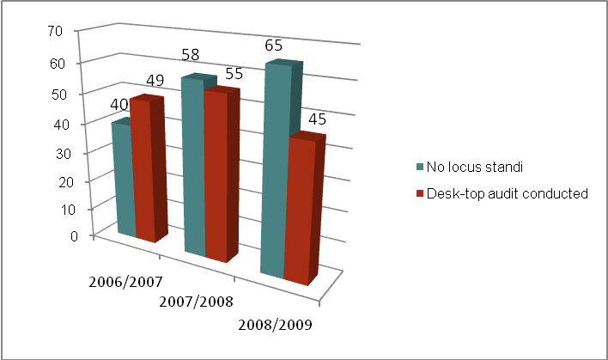  During desk-top audits, evidence was gathered in order to determine whether the allegations made were substantiated or not. In instances where the evidence did not support the allegations made, the PSC found the allegations to be unsubstantiated. The trend during the 2007/2008 financial year where the majority of complaints investigated and finalised were found to be unsubstantiated continued during 2008/2009. In this regard, 91% of complaints investigated and finalised were found not to be substantiated. The trend in this regard over the last three financial years is depicted in Table 15 below:  TABLE 15: OUTCOME OF INVESTIGATIONS AND DESK-TOP AUDITS CONDUCTED BY THE PSC  The analysis of trends on complaints lodged, as reflected in this Fact Sheet, should assist with the identification of risk areas in the Public Service. What clearly emerged from this Fact Sheet is that there is a dire need for the bolstering of the PSC’s investigative capacity. The PSC, given its important oversight responsibilities cannot be placed in a position for much longer where it has to rely on the cooperation of departments to the extent that it has been forced to do. More dedicated investigative capacity will allow the PSC to conduct full-scale investigations more frequently and to expedite the handling of complaints.  Although this is the second fact sheet produced by the PSC, it is the first report where statistics on complaints handled by another constitutional body, namely the Public Protector, were included. Not only did the PSC endeavour with the inclusion of such statistics to draw a comparison between work done in this regard by the Public Protector and the PSC, but it was also done in an effort to enhance Parliament’s oversight responsibilities. The PSC will in future fact sheets and reports of this nature continue to provide information in this regard.  Final Fact Sheet 08-09
  Sources | 2006/2007 |  | 2007/2008 |  | 2008/2009
  Anonymous complainants | 149 | (56%) | 86 | (54%) | 95 | (46%)
  Complainants who identified themselves | 119 | (44%) | 73 | (46%) | 113 | (54%)
  TOTAL | 268 |  | 159 |  | 208
  Sources | 2006/2007 |  | 2007/2008 |  | 2008/2009
  Anonymous complainants | 41 | (19%) | 34 | (19%) | 17 | (15%)
  Members of the public | 53 | (24%) | 71 | (41%) | 63 | (55%)
  Public servants | 97 | (44%) | 54 | (31%) | 30 | (26%)
  Legislatures/EAs | 19 | (9%) | 8 | (5%) | 4 | (4%)
  Own accord | 8 | (4%) | 7 | (4%) | -*
  TOTAL | 218 |  | 174 |  | 114
  Nature of complaint | 2006/2007 |  | 2007/2008 |  |  | 2008/2009
  Human Resource (HR) related | 49 | (18%) | 49 | (31%) | 30 |  | (14%)
  Unethical behaviour | 135 | (50%) | 74 | (46%) | 134 |  | (66%)
  Service delivery | 53 | (20%) | 25 | (16%) | 27 |  | (13%)
  Corruption/Maladministration | - |  | - |  | 5 |  | (2%)
  Unfair labour practice | 11 | (4%) | 3 | (2%) | 7 |  | (3%)
  Irregularities & discrimination | 5 | (2%) | 1 | (0.5%) | 1 |  | (0.5%)
  Pension enquiry | 3 | (1.5%) | 1 | (0.5%) | -
  Prison conditions | 4 | (1.5%) | 3 | (2%) | 1 |  | (0.5%)
  Grievance | 2 | (1%) | 3 | (2%) | 2 |  | (1%)
  Outcome of court case | 5 | (2%) | - |  | -
  TOTAL | 268 |  | 159 |  | 207*
  Nature of complaint |  | 2006/2007 |  | 2007/2008 |  | 2008/2009
  HR related | 74 |  | (37%) | 52 | (36%) | 32 | (29%)
  Unethical behaviour | 23 |  | (11.5%) | 16 | (11%) | 11 | (10%)
  Service delivery | 16 |  | (8%) | 30 | (20.5%) | 17 | (15%)
  Corruption/Maladministration | 22 |  | (11%) | 28 | (19%) | 22 | (20%)
  Unfair labour practice | 20 |  | (10%) | 8 | (5.5%) | 10 | (9%)
  Irregularities & discrimination | 29 |  | (14.5%) | 5 | (3%) | 9 | (8%)
  Pension enquiry | 9 |  | (4.5%) | 3 | (2%) | 4 | (3%)
  Prison conditions | - |  |  | 1 | (1%) | 1 | (1%)
  Grievance | - |  |  | - |  | 3 | (3%)
  Outcome of court case | 7 |  | (3.5%) | 3 | (2%) | 2 | (2%)
  TOTAL | 200 |  |  | 146 |  | 111
  Nature of complaint |  | NACH |  | Complaints  Rules |  | TOTAL
  HR related | 30 |  | (14.5%) | 32 | (28%) | 62 | (19.5%)
  Unethical behaviour | 134 |  | (64.5%) | 11 | (10%) | 145 | (46%)
  Service delivery | 27 |  | (13%) | 17 | (15%) | 44 | (14.5%)
  Corruption/Maladministration | 5 |  | (2.5%) | 22 | (19.5%) | 27 | (8%)
  Unfair labour practice | 7 |  | (3.5%) | 10 | (9%) | 17 | (5%)
  Irregularities & discrimination | 1 |  | (0.5%) | 9 | (8%) | 10 | (3%)
  Pension enquiry | - |  |  | 4 | (3.5%) | 4 | (1%)
  Prison conditions | 1 |  | (0.5%) | 1 | (1%) | 2 | (0.5%)
  Grievance | 2 |  | (1%) | 3 | (3%) | 5 | (2%)
  Outcome of court case | - |  |  | 2 | (2%) | 2 | (0.5%)
  TOTAL | 207 |  |  | 111 |  | 318
  Status of complaint | 2006/2007 |  | 2007/2008 |  | 2008/2009
  Complaints finalised & closed | 30 | (7%) | 36 | (23%) | 52 | (25%)
  Referred to departments to investigate | 194 | (41%) | 64 | (40%) | 65 | (31%)
  Still in progress | 44 | (9%) | 30 | (19%) | 48 | (23%)
  No feedback received & reminder sent | 147 | (31%) | 23 | (14%) | 23 | (11%)
  Receipt acknowledged by departments | 55 | (12%) | 6 | (4%) | 20 | (10%)
  Status of complaint |  | 2006/2007 |  | 2007/2008 |  | 2008/2009
  Complaints finalised & closed | 88 |  | (35%) | 103 | (59%) | 68 | (60%)
  Referred to departments to investigate | 28 |  | (11%) | 29 | (17%) | 13 | (11%)
  Still in progress | 130 |  | (52%) | 33 | (19%) | 28 | (24%)
  No feedback received & reminder sent | 3 |  | (1%) | 7 | (4%) | 2 | (2%)
  Receipt acknowledged by departments | - |  |  | 2 | (1%) | 3 | (3%)
  Number of complaints - | Public Protector | PSC
  Number of complaints - | 2007/2008  2007/2008 | 2008/2009
  Lodged | 13 223 | 333 | 322
  Finalised | 11 308 (85%) | 139 (42%) | 120 (37%)
  National/ Provincial | Department | No of complaints
  National/ Provincial | Department | NACH | Complaints Rules
  Eastern Cape | Education | 1 | -
  Eastern Cape | Health | 1 | -
  Gauteng | Agriculture | 1 | -
  Gauteng | Health | 2 | -
  Mpumalanga | Public Works, Roads & Transport | 1 | -
  National | Correctional Services | 3 | -
  National | Health | 1 | -
  National | Home Affairs | 1 | -
  National | Justice & Constitutional Development | 3 | 1
  National | South African Police Service | 5 | -
  National | Trade & Industry | 1 | -
  National | Transport | 1 | -
  National | Water Affairs & Forestry | 2 | 1
   | TOTAL | 23 | 2
  Reason for finalizing/  closing complaint | 2006/2007 |  | 2007/2008 |  | 2008/2009
  Outside PSC’s constitutional mandate | 12 | (40%) | 3 | (8%) | 29 | (56%)
  Desk-top audit conducted | 9 | (30%) | 25 | (69%) | 19 | (36%)
  Desk-top audit & investigation conducted | - |  | 1 | (3%) | -
  Complaint lacking in detail | 2 | (7%) | - |  | 1 | (2%)
  Duplication or add-on: Existing complaint | 7 | (23%) | 7 | (20%) | 3 | (6%)
  Complaint withdrawn | - |  | - |  | -
  TOTAL | 30 |  | 36 |  | 52
  Reason for finalizing/  closing complaint | 2006/2007 |  |  | 2007/2008 |  |  | 2008/2009
  Outside PSC’s constitutional mandate | 28 | (32%) | 55 |  | (53%) |  | 36 | (53%)
  Desk-top audit conducted | 40 | (45%) | 30 |  | (29%) |  | 26 | (38%)
  Desk-top audit & investigation conducted | 20 | (23%) | 10 |  | (10%) |  | -*
  Complaint lacking in detail | - |  | 7 |  | (7%) |  | 5 | (7%)
  Add-on: Existing complaint | - |  | - |  |  |  | 1 | (2%)
  Complaint withdrawn | - |  | 1 |  | (1%) |  | -
  TOTAL | 88 |  | 103 |  |  |  | 68
  Complaints, upon investigation, found to be – | Financial year
  Complaints, upon investigation, found to be – | 2006/2007 | 2007/2008 | 2008/2009
  substantiated | 63% | 29% | 9%
  unsubstantiated | 37% | 71% | 91%

Republic of South Africa. Public Service Commission. Trend analysis on complaints lodged with the Public Service Commission during the 2004/2005 and 2005/2006 financial years. Pretoria. October 2006.
Republic of South Africa. Public Service Commission. Trend analysis on complaints lodged with the Public Service Commission during the 2006/2007 financial year. Pretoria. October 2007.
Republic of South Africa. Public Service Commission. Monitoring Fact Sheet on complaints lodged with the Public Service Commission during the 2007/2008 financial year. Pretoria. July 2008.
Public Protector South Africa. Annual Report. 1 April 2007 – 31 March 2008.
Public Protector South Africa. Annual Report. 1 April 2007 – 31 March 2008.

